LOCATION : NATIONWIDE
DATE : 16.02.2018
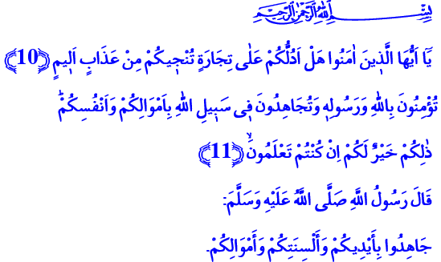
JIHAD: THE STRUGGLE IN ALLAH’S CAUSE WITH ONE’S LIFE AND WEALTH
Jumu’ah Mubarak, Honorable Believers!
A Companion came to our Prophet (s.a.w.) and asked: “What do you think of a man who fights seeking both fame and spiritual rewards? What does he gain?” The Messenger of Allah replied, “He will gain nothing.” But the man repeated the question three times. Therefore, our Prophet said: “Allah does not accept any deed, except that which is purely for Him, and seeking His countenance.”
Honorable Believers!
Jihad is the name of the effort spent on Allah’s path, the struggle made for the cause of the Truth. Jihad is the endeavor of a believer to win Almighty Lord’s countenance by using every means of his existence. Jihad is to show the determination with one’s body, tongue, ideas and heart to protect all that is sacred.
Jihad is not a struggle for an unjust attack, destruction, exploitation or oppression. On the contrary, it is the will of a Muslim to live in his/her homeland with his/her honor, identity, and freedom; to protect his/her faith, flag, independence and dignity. Jihad is the effort of a nation to protect its rights against oppression and the oppressors. It is the cause of lifting the truth up, and spreading peace, comfort, justice, and goodness on earth.
Esteemed Muslims!
Our Almighty Lord enjoins us in the Qur’an that people who believe in Allah and His Messenger strive for the cause of Allah with their wealth and their lives. Our Prophet (s.a.w.) says: “Strive in Jihad with your hands, your tongues and your wealth.” This verse and hadith show that jihad is not always achieved by sacrificing one’s life, it can also be achieved by serving the truth with one’s hands or tongue or wealth.
The hadith “Mujahid is the one who strives against his own soul.” tells us that our jihad starts against our own desires first. The whispers of our nafs urge us towards badness, faults and rebellion; and struggling against them is a jihad as well. It is also a jihad to learn the religion of Allah from the truest source and live it in the most beautiful way. It is also a jihad to stand against the wants and desires that would alienate us to our creation and drive us to an endless abyss. Moreover, if a believer succeeds in the jihad with one’s own soul, then s/he will succeed in the jihad against the enemies of Islam as well.

Dear Brothers and Sisters!
The jihad is made to spread the life-giving principles of Islam on earth and to end injustice sometimes by pens, and sometimes by words. A believer works and strives for the Truth at times with his/her hand, and at times with his/her wealth. S/he works day and night to tell the truth, to call people to goodness, and conduce to good things. The highest level of the jihad is the armed struggle for one’s faith, existence, motherland, continuity, and freedom. The struggle we have made as a nation with its East, West, North, and South to protect this honorable motherland is the most vivid witness of jihad. Çanakkale, which we came out victorious with the help of Allah, is the name of the epic of existence, faith, courage, and determination.
Honorable Believers!
Jihad does not mean to take a weapon in hand and murder innocents. Some people have tried to attribute the suicide attacks, violence and savagery committed by the murderous gangs in the recent years to Muslims, but these things are not even remotely connected to the concept of jihad in Islam. Because in Islam, jihad is the name of the struggle to let live, not to kill; and to revive, not to destroy. Jihad is performed only to remove any evil that deviates humans from their purpose of creation. Whoever they may be and regardless of its purpose, attacks against innocent people would never comply with the supreme essence and ideals that Islam has ascribed to the concept of jihad. These are brutal murder attempts committed against humanity.
Esteemed Brothers and Sisters!
Today, we are striving with our lives and our wealth for existence as a nation. Our Mehmetçiks (soldiers) showed the whole world once again that we would sacrifice ourselves for our faith, our flag, and our motherland without hesitation. Each son of this motherland who has been honored with martyrdom at a very young age almost shouts out the glad tidings of our Lord to us: “And say not of those who are slain in God's cause, ‘They are dead’: nay, they are alive, but you perceive it not.”
Honorable Believers!
We all have our responsibilities in this struggle for survival. By this responsibility, let us sincerely ask Allah Almighty together in this hour of holy Jumu’ah:
O Allah! Grant victory to our heroic army who has been fighting for our independence and our future, for our unity and solidarity! Grant Your Mercy to our honorable martyrs who sacrificed their lives to protect our peace and values; and bless our veterans with recovery. Grant us sagacity, foresight, strength and wisdom against those who seek sedition, malice and mischief, and those who tricks and set traps against our nation and the ummah of the Prophet! Grant us the honor to be among your sincere servants who comprehend the true meaning of jihad and do not escape from the struggle and endeavor for your cause!
Our Lord! In You we believe and in You we put our trust. Do not leave us without Your Mercy!

Nasa’i, Jihad, 24.
Saff, 61/11.
Nasa’i, Jihad, 48.
Tirmidhi, Virtues of Jihad, 2.
Baqarah, 2/154. Issued by: General Directorate of Religious Services

